INERNET PROTOCOL-IP

|  |  |
| --- | --- |
| Reviewed by | V. Mamatha |
| Prepared by | M. Venkatanarayana |

IP-Stands for internet protocol

It works in layer three(l3) of OSI model reference.

Internet-The Internet is a whole network that connects computers all over the world. Through the Internet, people can share information and communicate from anywhere with an Internet connection.

Internet is a global network that connects billions of computers across the world with each other and to the World Wide Web. It uses standard internet protocol suite (TCP/IP) to connect billions of computer users worldwide. It is set up by using cables such as optical fibres and other wireless and networking technologies. At present, internet is the fastest mean of sending or exchanging information and data between computers across the world.

Protocol- A protocol is a set of rules and guidelines for communicating data. Rules are defined for each step and process during communication between two or more computers. Networks have to follow these rules to successfully transmit data.

Ip address- An IP address is a unique address that identifies a device on the internet or a local network. IP stands for "Internet Protocol," which is the set of rules governing the format of data sent via the internet or local network.

IP ADDRESSES HANDLED BY “IANA"

IP VERSIONS

IANA------🡪INTERNET ASSIGNED NUMBERS AUTHORITY

IP ADDRESS: - All the computers of the world on the Internet network communicate with each other with underground or underwater cables or wirelessly. If I want to download a file from the internet or load a web page or literally do anything related to the internet, my computer must have an address so that other computers can find and locate mine in order to deliver that particular file or webpage that I am requesting. In technical terms, that address is called **IP Address or Internet Protocol Address.**

IP ADDRESS ASSIGNED BY ISP (INTERNET SERVICE PROVIDER)

For IPv4, this pool is 32-bits (232) in size and contains **4,294,967, 296 IPv4 addresses**.

TYPES OF IP ADDRESSES(IPV4) :-

IP ADDRESSES

STATIC IP PUBLIC IP

PRIVATE IP

STATIC IP: -These static IP address are assigned by manually and some static ip addresses are we have to buy from ISP.(internet service provider).once we assign static ip we unable change it. these will we fixed IP addresses.

Ex: -websites, VPN services, printers, servers, ethernet cable.

PUBLIC IP: - The unique, Internet-facing IP address assigned to your device by your ISP. A public IP Address means it can be reached through the Internet. Public ip cannot be same at any time and any Where.

Ex: -Computers, Routers, Access point, laptops, mobiles.

PRIVATE IP: - Private IP addresses let devices connected to the same network communicate with one another without connecting to the entire internet. DHCP provides this private IP. By making it more difficult for an external host or user to establish a connection, private IPs help bolster security within a specific network, like in your home or office. It can be same in different networks also.

Ex : - DHCP , laptop , mobiles.

IPV4 ADDRESS FORMAT :-

1B.1B.1B.1B=32bits 1B=8bits

1 OCTET=8bits

232 =**4,294,967,296**

4BYTES

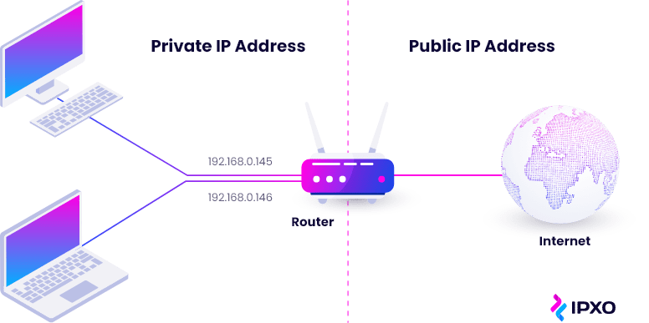

LINK 1: - <https://youtu.be/Xmi8B9hL40E>

LINK 2: - https://youtu.be/pUvOnz9Lnx8